1. **Check if the number is a positive integer or not.**

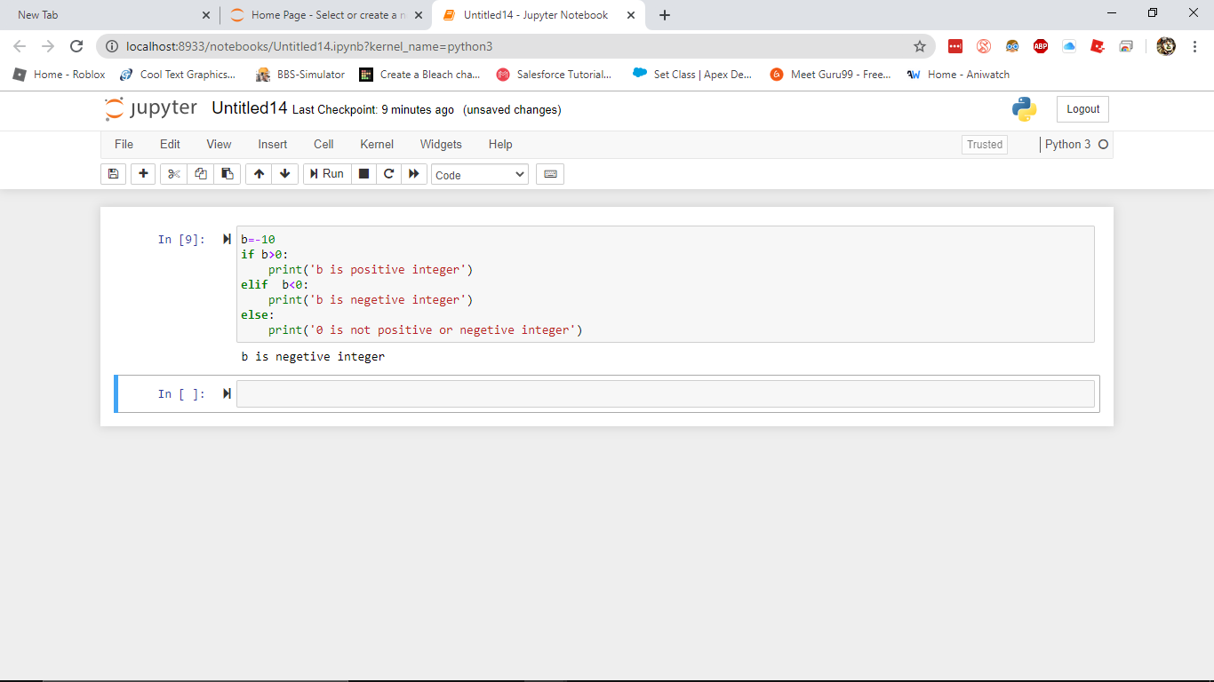

**2 .Check if the number is odd or even**

* 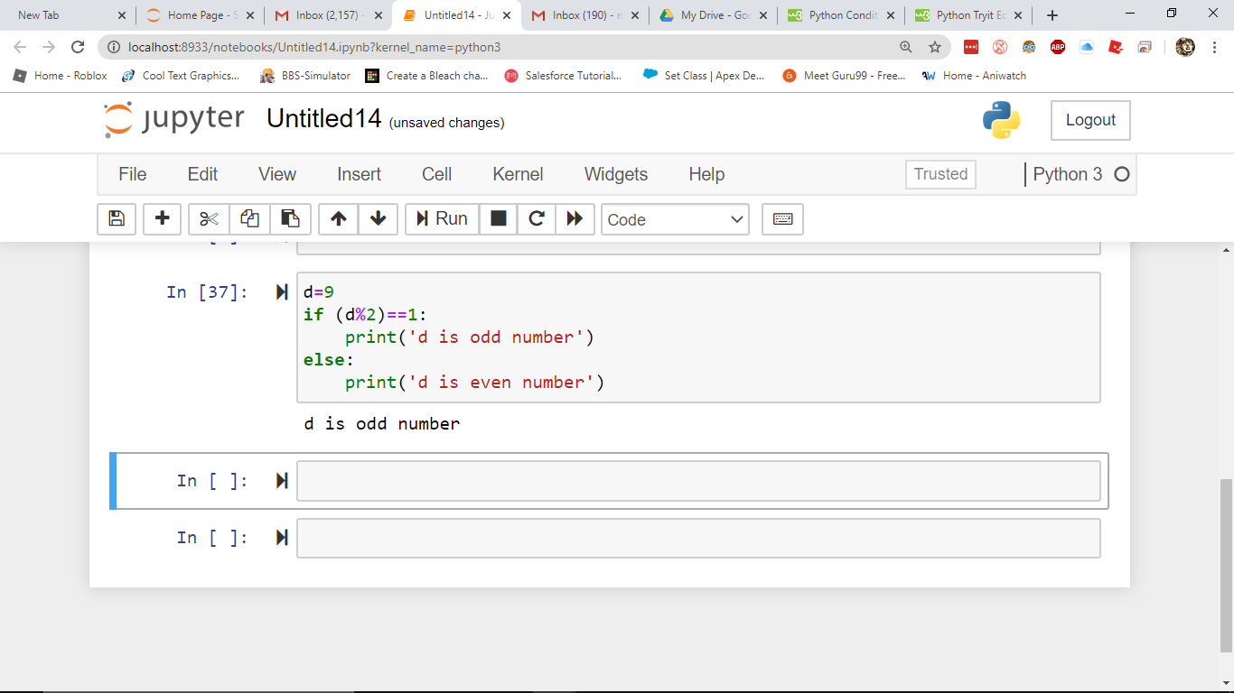

1. ***checkfor a  leap year***

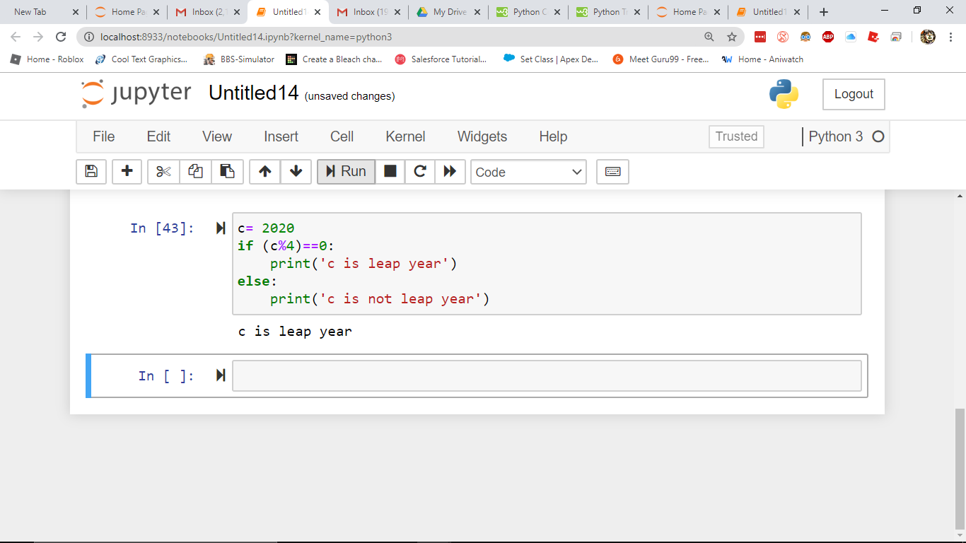

***4. Take 3 input from the user and print the largest one***

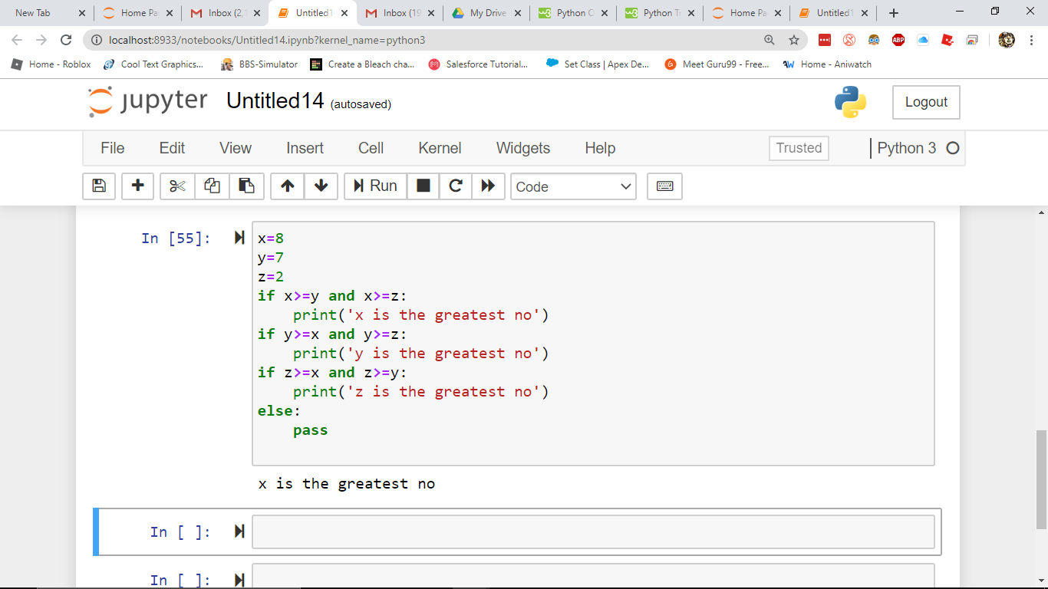

1. ***Factorial of a number***

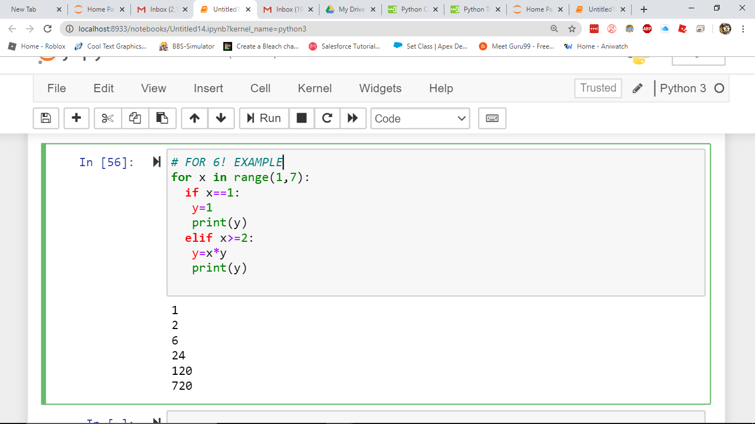

***5.Take a number print the last 10 digits(using for and while)***

***For loop***

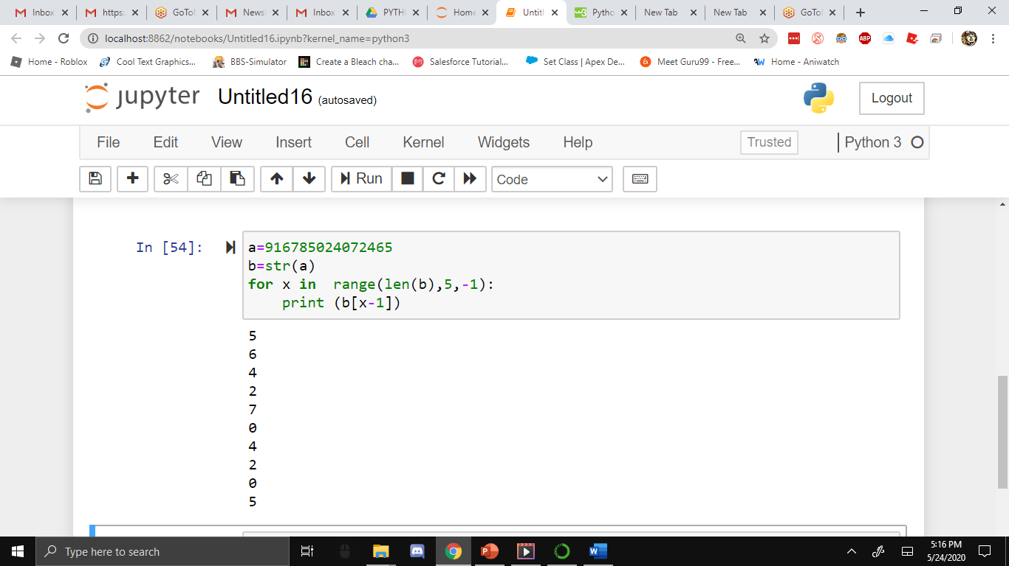

***5.Take a number print the last 10 digits(using for and while)***

***For loop***

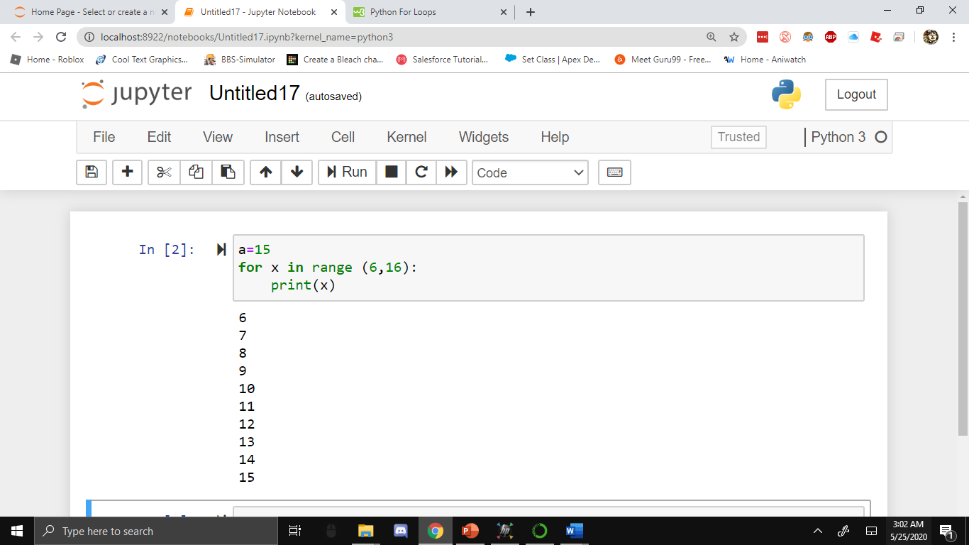

***While loop (Take a number print the last 10 digits)***

